2021
Electrical Safety Coloring/Drawing Contest
Entries must be submitted no later than May 28, 2021.
No late entries will be considered.

Please return the entire application.

Contestant Information
Contestant Name:

Address:

School Attending:

Parent Name(s):

Acct. #:_____________________ Age: _______ Grade Level: ____________________________

Name of Parent/Guardian:

I permit/release my child’s name, image and artwork to Sumner-Cowley Electric for publication purposes.

Parent/Guardian’s Signature: Date:

Contest Overview
To help promote May as Electrical Safety Month and to encourage discussions about electrical safety between parents and their children, Sumner-Cowley Electric is conducting an electrical safety drawing contest.

Contestants will be divided into two groups: Kindergarten through 2nd grade; 3rd grade through 5th grade. The first-place winner in each group will receive a $25 Walmart gift card and the second-place winners will receive a $20 Walmart gift card. The winners will have their drawing featured on Sumner- Cowley's website, Facebook page and in an upcoming issue of Kansas Country Living Magazine.

Applications and artwork will not be considered unless all required information is furnished.

Artwork can be submitted my mail (PO Box 220 Wellington, KS 67152), in person at our headquarters or by email at jaredm@sucocoop.com.

All drawings must be submitted no later than May 28, 2021.

No late drawings will be considered. The winners will be announced on June 1, 2021.

Eligibility Requirements
Each contestant must be a student who resides in Sumner-Cowley's service territory and must be the child of a Sumner-Cowley member.

Winners will be selected by Sumner-Cowley Electric employees.

Artwork Guidelines for K – 2nd Grade Group

Contestant must use the provided coloring sheet

Artwork Guidelines for 3rd – 5th Grade Group

- Must be original

- Must use the provided drawing paper format

- Must be related to a specific electrical safety tip

- No computer-generated artwork will be considered

- Artwork may be in color or black/white

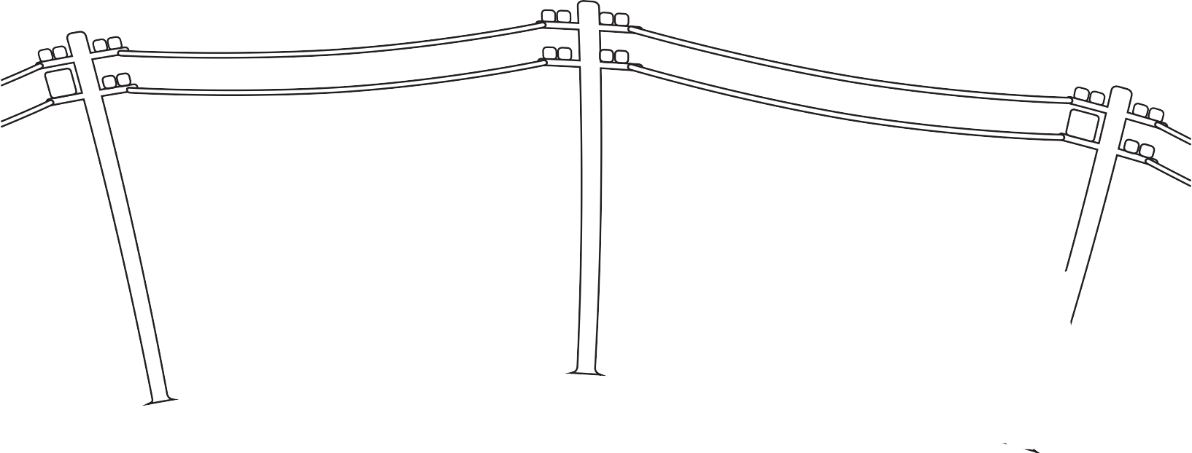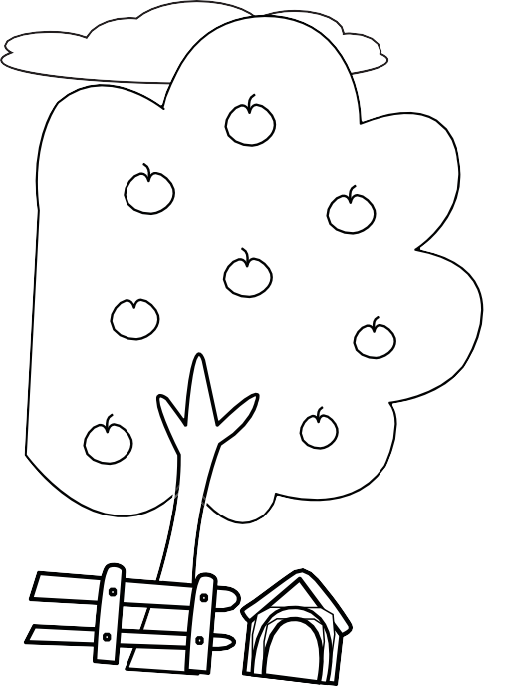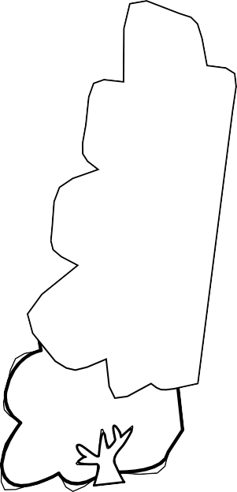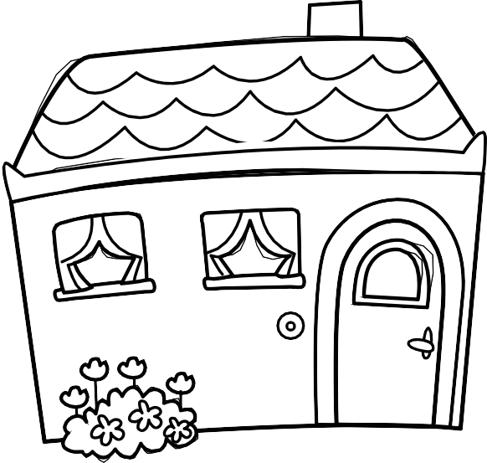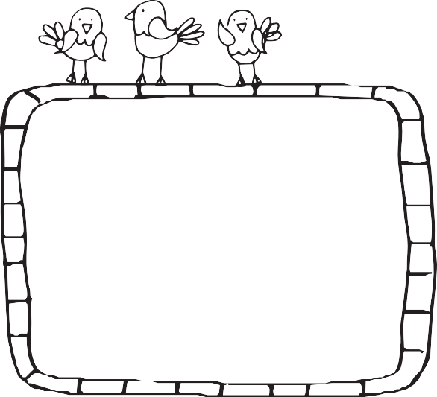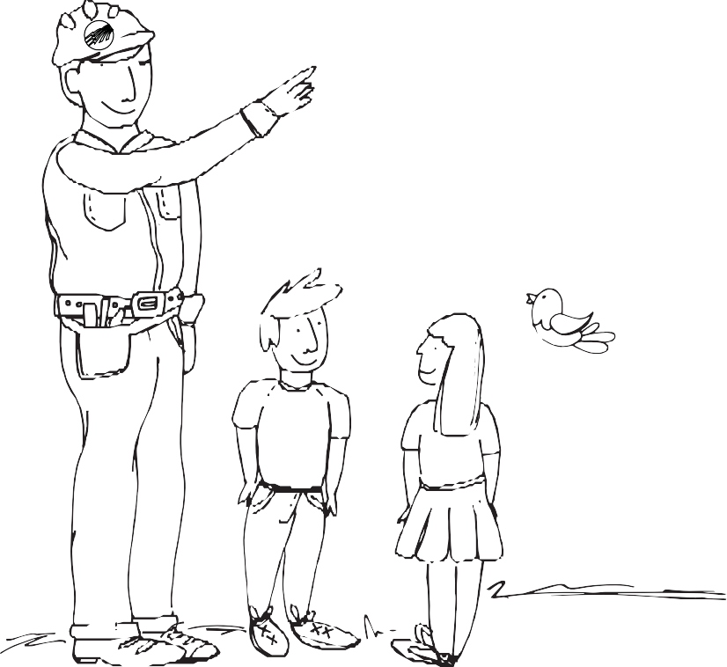

2021 Electric Safety Coloring Contest
(K - 2nd Grade Template)

Spring Safety Tip:
Never climb a tree that has power lines running through it! Always avoid playing near electrical utility equipment.

2021 Electric Safety Drawing Contest
(3rd - 5th Grade Template)

Contestant Name: Grade: Age:

