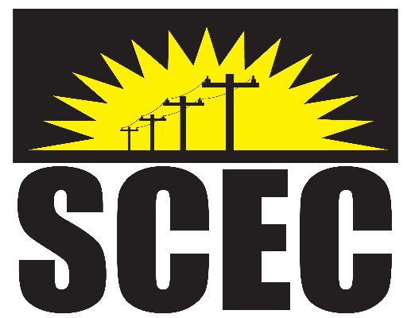
2024
COOP MONTH
COLORING CONTEST
Entries must be submitted no later than TUESDAY OCTOBER 22, 2024

Please return the entire application.
CONTESTANT INFORMATION
Contestant Name:_______________________________________________________
Address:________________________________________________________________
School Attending:________________________________________________________
Parent(s) Name(s):_______________________________________________________
Acct#:___________________________ Age:______ Grade Level:________________

I permit/release my child’s name, image and artwork to Sumner-Cowley Electric for publication purposes.

Parent/Guardian Signature:_______________________________________________
Date:_____________________

